Given the head of a linked list and a value x, partition it such that all nodes **less than** x come before nodes **greater than or equal** to x.

You should **preserve** the original relative order of the nodes in each of the two partitions.

**Example 1:**

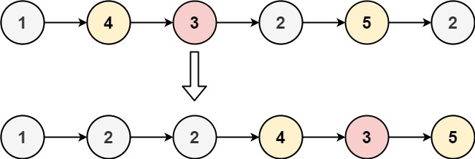

Input: head = [1,4,3,2,5,2], x = 3  
Output: [1,2,2,4,3,5]

**Example 2:**

Input: head = [2,1], x = 2  
Output: [1,2]

**Constraints:**

* The number of nodes in the list is in the range [0, 200].
* -100 <= Node.val <= 100
* -200 <= x <= 200